**, Analyzing Time Complexity**

**Project - Mid Term Report**

**BACHELOR OF TECHNOLOGY**

****(Artificial Intelligence and Machine Learning)

**SUBMITTED BY:**

Vaishnavee (2330661)

Vanshika (2330662)

Utsav Raj (2330660)

Upender (2330659)

Tushar (2330658)

**4th April, 2025**

**Under the Guidance of**

Mr. Mayank Chauhan

(Assistant Professor)

**Department of Artificial Intelligence and Machine Learning**

**Chandigarh Engineering College Jhanjeri Mohali - 1040307**

**Table of Contents**

|  |  |  |
| --- | --- | --- |
| **S.No.** | **Contents** |  |
| **1.** | **Introduction** |  |
| **2.** | **Brief Literature survey** |  |
| **3.** | **Problem formulation** |  |
| **4.** | **Objectives** |  |
| **5.** | **Methodology/ Planning of work** |  |
| **6.** | **Facilities required for proposed work** |  |
| **7.** | **References** |  |

**Abstract:**

Time complexity analysis is a fundamental concept in the study of algorithms, providing insights into the efficiency and scalability of computational processes. This paper explores various techniques for analyzing the time complexity of algorithms, focusing on the classification of algorithms into different complexity classes such as constant, linear, logarithmic, quadratic, and exponential time. By examining the relationship between input size and execution time, the paper highlights the significance of asymptotic notations—Big O, Big Theta, and Big Omega—used to express the upper, tight, and lower bounds of an algorithm's performance. Additionally, the study investigates common strategies for optimizing algorithmic efficiency, including divide-and-conquer, dynamic programming, and greedy methods. Through a series of examples and case studies, the paper demonstrates how time complexity analysis can guide algorithm selection and influence the design of efficient software systems. The findings contribute to a deeper understanding of computational complexity, offering practical approaches to improving algorithmic performance in real-world applications.

**Introduction**

**The Impact of Input Size and Order on the Time Complexity of Algorithms**

Time complexity is a fundamental aspect of analyzing the performance of algorithms, providing insights into how well an algorithm scales with increasing input size. For software engineers, developers, and data scientists, understanding the time complexity of an algorithm is essential for selecting the most efficient method for solving a problem. Given that computational resources such as processing power and memory are finite, making efficient use of these resources is crucial, especially when dealing with large datasets or time-sensitive applications. Time complexity, typically expressed using Big O notation, provides a way to understand an algorithm’s growth rate in relation to the size of the input, offering a high-level view of its performance.

**The Influence of Input Size:**

The size of the input data is one of the most critical factors influencing an algorithm's performance. As the size of the input grows, the execution time of an algorithm can increase dramatically, particularly for algorithms with higher time complexities. For example, consider **Bubble Sort**, a simple sorting algorithm with an average-case time complexity of O(n²). This quadratic growth results from the algorithm's approach of repeatedly comparing and swapping adjacent elements. While this makes Bubble Sort easy to implement, its inefficiency becomes apparent when working with large datasets.

In contrast, algorithms such as **Merge Sort**, which has a time complexity of O(n log n), scale much more efficiently as the input size increases. Merge Sort employs a divide-and-conquer strategy, recursively splitting the input data into smaller subarrays and merging them back together in sorted order. This results in logarithmic growth in the number of operations, making it much more efficient for larger datasets compared to Bubble Sort. However, even Merge Sort is not immune to performance pitfalls. **Quick Sort**, with an average-case time complexity of O(n log n), is often faster than Merge Sort due to its in-place partitioning. However, Quick Sort’s worst-case complexity can degrade to O(n²) if poor pivot choices are made, resulting in unbalanced partitions that slow down execution. This variability in performance highlights why it’s important to not only rely on theoretical time complexity but to also consider input size and the specific nature of the problem at hand.

**The Influence of Input Order:**

In addition to input size, the arrangement of the data itself can also dramatically affect an algorithm's performance. Many algorithms, particularly sorting algorithms, exhibit different behaviors depending on whether the input is already sorted, nearly sorted, randomly ordered, or sorted in reverse.

For instance, **Bubble Sort** behaves optimally when the input data is already sorted or nearly sorted. In the best-case scenario, Bubble Sort operates with a time complexity of O(n) since it only needs a single pass through the dataset to verify that no swaps are necessary. However, in the worst case, where the data is sorted in reverse order, Bubble Sort’s time complexity increases to O(n²), as it performs many more comparisons and swaps. This sensitivity to input order means that Bubble Sort can be highly inefficient in scenarios where the data is not in an ideal arrangement, despite its simplicity.

Similarly, **Quick Sort** performs well on randomly ordered data, typically exhibiting a time complexity of O(n log n). However, its performance can degrade significantly if the pivot element is poorly chosen. In the worst case, where the pivot consistently results in unbalanced partitions (such as always picking the smallest or largest element), Quick Sort can degrade to O(n²) time complexity. This situation can arise when the input data is sorted or nearly sorted, leading to imbalanced partitions and inefficient sorting. Despite these pitfalls, Quick Sort remains one of the most widely used sorting algorithms due to its average-case efficiency and the potential for optimizations, such as randomized pivot selection or hybrid algorithms that switch to other sorting methods when necessary.

On the other hand, **Merge Sort** exhibits a consistent time complexity of O(n log n), regardless of the input order. This stability makes Merge Sort a reliable choice for situations where the input data could be ordered in any way. Its divide-and-conquer approach ensures that the time complexity remains predictable, even in the worst-case scenario. This feature makes Merge Sort particularly useful when the input data is highly variable or when it is important to guarantee consistent performance.

**Importance of Comprehensive Analysis:**

While time complexity analysis provides a valuable theoretical framework for understanding algorithm performance, it does not tell the entire story. In practice, algorithms can behave very differently depending on the input size and the arrangement of the data. A deep understanding of how an algorithm performs under various conditions is crucial for selecting the best algorithm for a given task. A single worst-case or average-case complexity is not enough to capture the full spectrum of an algorithm’s behavior, especially in real-world scenarios where input conditions can vary significantly.

This paper aims to explore these complexities by analyzing three widely used sorting algorithms—**Quick Sort**, **Merge Sort**, and **Bubble Sort**—under a variety of input sizes and input orders. Through both theoretical analysis and empirical testing, this study seeks to provide a more comprehensive understanding of how these algorithms perform in practice, considering factors such as input size, data order, and execution time. Specifically, the research will address:

1. The impact of input size on algorithm performance and scalability.
2. How different input orders (e.g., sorted, random, reverse-ordered) influence the efficiency of the algorithm.
3. Which sorting algorithms are most suited for specific real-world scenarios based on input characteristics.

By examining these aspects, this study will provide a more nuanced view of algorithmic performance, offering practical insights for algorithm selection and optimization in real-world applications. The goal is to demonstrate the importance of considering both theoretical complexity and empirical results when choosing algorithms for tasks where efficiency is critical.

**Literature Survey**

**The Impact of Input Size and Order on Algorithm Time Complexity**:

The study of algorithm efficiency has been a critical area of research in computer science for decades. Numerous studies have been conducted to evaluate how different input sizes and orders affect the time complexity of algorithms. The efficiency of an algorithm is not solely determined by its worst-case or average-case complexity; instead, various factors such as input arrangement, real-world data structures, and hybrid approaches play a crucial role in determining actual execution time.

**Early Foundations of Asymptotic Analysis:**

One of the earliest formal approaches to analyzing algorithm performance was introduced by Donald Knuth (1968) in his seminal work The Art of Computer Programming. Knuth pioneered asymptotic analysis, a mathematical approach to classifying algorithms based on how their runtime grows with increasing input size. This foundational work introduced Big O notation, which has since become a standard tool for evaluating algorithm efficiency.

However, early asymptotic analysis primarily focused on input size rather than input order or structure. It provided a high-level theoretical understanding but did not fully capture the variations in execution time caused by different input arrangements.

**Expanding the Scope: Input Order and Structure**

Building on Knuth’s work, researchers began exploring the role of input order in determining algorithm performance. Robert Sedgewick (1983) conducted a comprehensive study of sorting algorithms under varying input conditions. His work demonstrated that an algorithm’s time complexity could fluctuate significantly depending on whether the data was sorted, reverse sorted, or completely unordered.

For example, Quick Sort, while often considered one of the most efficient sorting algorithms, performs poorly on already sorted or reverse-sorted data due to its unbalanced partitioning, degrading to O(n²) complexity. In contrast, Merge Sort, with its consistent O(n log n) complexity, maintains stable performance regardless of input order, making it preferable in scenarios where worst-case efficiency is a concern.

**Modern Developments: Hybrid Algorithms and Real-World Data Patterns**

Recent advancements in algorithm analysis have extended beyond theoretical studies to practical applications. Cormen et al. (2009) in Introduction to Algorithms expanded on previous research by examining hybrid sorting algorithms, such as IntroSort, which combines Quick Sort, Heap Sort, and Insertion Sort to optimize performance based on input conditions. Their findings reinforced the importance of input characteristics in determining real-world efficiency.

In addition, modern research has explored how algorithms behave when applied to real-world data structures rather than purely theoretical datasets. Studies have shown that certain algorithms excel in handling nearly sorted data, leading to the development of adaptive sorting algorithms like Tim Sort, which dynamically adjusts its approach based on input characteristics.

**Case Studies on Sorting Algorithms:**

The literature consistently emphasizes that input size and order significantly impact sorting algorithm efficiency. Some notable findings include:

Quick Sort, with its O(n log n) average case, suffers performance degradation (O(n²)) on sorted or reverse-sorted inputs if the pivot is chosen poorly.

Merge Sort maintains a stable O(n log n) complexity regardless of input order, making it more predictable but requiring additional space.

Heap Sort also runs in O(n log n) but is often slower in practice due to higher constant factors in its operations.

Bubble Sort, with its worst-case O(n²) complexity, performs significantly better (O(n) best case) on nearly sorted data due to early termination through swaps.[2]

**Significance of Comprehensive Algorithm Analysis:**

The findings from these studies highlight the necessity of understanding algorithm behavior beyond theoretical complexity classes. In performance-critical applications—such as database indexing, large-scale data processing, and real-time systems—choosing an algorithm based on real input patterns rather than just worst-case complexity is crucial.

Moreover, the emergence of machine learning-driven algorithm selection has opened new research avenues. Modern systems can now analyze historical data patterns and dynamically select the most efficient algorithm for a given dataset.

**Problem Formulation**

The primary focus of this research is to examine how variations in input size (small, medium, large) and input order (random, sorted, reverse sorted) influence the time complexity of commonly used sorting algorithms. Sorting algorithms are fundamental to numerous applications, and understanding their behavior under different conditions is crucial for optimizing their use in real-world problems. This study specifically aims to explore the time complexity in various scenarios, including best-case, average-case, and worst-case performance.

Given the diversity of input characteristics and the importance of efficient algorithms in today’s data-driven world, it is critical to understand how specific input configurations impact the performance of different sorting algorithms. Algorithms that perform well in one scenario may underperform in another, depending on factors such as the arrangement of input data or the size of the dataset. By considering these factors, the study aims to provide insights that will help in selecting the most appropriate algorithm for specific tasks.

**Problem Definition**

The core problems this project addresses include:

- Lack of intuitive, interactive tools for learning sorting algorithms.

- Difficulty in understanding how sorting performance changes with input size.

- Limited exposure to the intersection between algorithms and machine learning in undergraduate education.

This system seeks to tackle all these areas by combining animation, performance tracking, and regression-based prediction into one unified tool.

**Research Methodology and Approach**

To answer these questions, we will conduct a series of controlled experiments using three widely used sorting algorithms—**Bubble Sort**, **Quick Sort**, and **Merge Sort**. These algorithms were chosen because they represent different classes of time complexity (quadratic, logarithmic, and linearithmic) and are commonly used in practical applications.

For each algorithm, the study will test its performance under three different input sizes: small (10-100 elements), medium (500-1000 elements), and large (5000+ elements). Each input size will be tested under three different input orders: random, sorted, and reverse sorted. The performance of each algorithm will be measured in terms of execution time, and the results will be analyzed to determine how time complexity varies with input size and order.

**Objectives**

The main objectives of this study are: This study aims to provide a deeper understanding of how sorting algorithms perform under various conditions, focusing on real-world scenarios rather than just theoretical analysis. The key objectives of the research are:

* Visually demonstrate how sorting algorithms work.
* Allow users to control input array size and algorithm selection.
* Measure and store the time each sorting algorithm takes to complete.
* Train a regression model using collected data.
* Predict performance for future inputs using polynomial regression.
* Plot real vs. predicted results to visualize trends.

**Methodology**

Methodology of our research involves the following steps:

**Selection of Algorithms**

The algorithms selected for this analysis includes:

* **Quicksort**: A divide-and-conquer algorithm that segregates the data with help of a pivot and has O(n log n) time complexity but can degrade to O(n²) in the worst-case scenario.
* **Merge Sort**: A stable, divide-and-conquer algorithm with a consistent O(n log n) time complexity.
* **Bubble Sort**: This bubbles up the largest element to the last.It has an average and worst-case time complexity of O(n²).

**Input Sizes**

The study will consider three different input sizes:

* **Small**: 100 elements
* **Medium**: 1000 elements
* **Large**: 10,000 elements

**Input Orders**

Each input size will be tested across three different input orders:

* **Random**: Data is arranged in a random order.
* **Sorted**: Data is already sorted in ascending order.
* **Reverse Sorted**: Data is arranged in descending order.

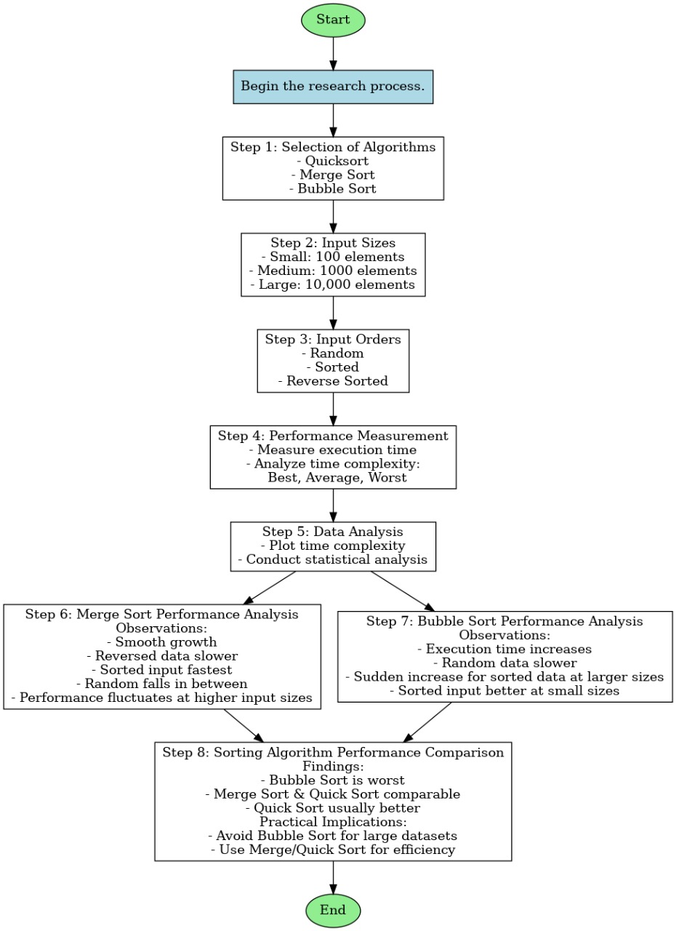

**Performance Measurement**

For each algorithm and input configuration, the execution time should be measured and the time complexity will be analyzed using the following approach:

The algorithm will be executed multiple times with varying input sizes, and the execution time will be recorded. These recorded times will then be analyzed to identify patterns and trends. Finally, the observed trends will be compared with theoretical complexity classes to determine the algorithm's efficiency using the following.

* **Best-case Time Complexity**: This will be measured when the input is sorted for algorithms like QuickSort and MergeSort.
* **Average-case Time Complexity**: This will be calculated by measuring the time across random inputs.
* **Worst-case Time Complexity**: This will be observed when the input is reverse sorted, for algorithms like QuickSort.

**Data Analysis**

The time complexity will be plotted for each scenario, comparing the performance of different algorithms. A detailed statistical analysis will be conducted to understand how input size and order impact the overall performance.

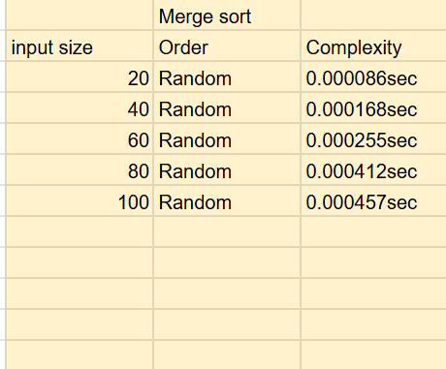 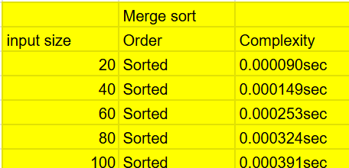

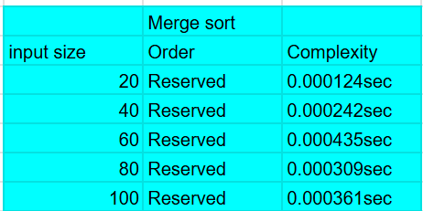

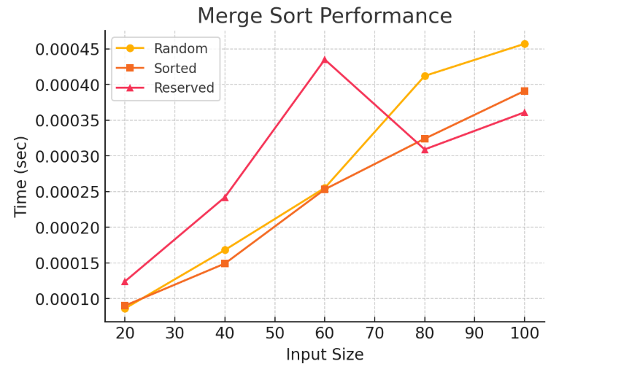

**Merge Sort Performance Analysis**

The graph shown above illustrates the performance of the Merge Sort algorithm when sorting different types of input data: Random, Sorted, and Reversed. The x-axis represents the input size and the y-axis is used to represent the time taken by the sorting process. Going through the trends in the graph, we can see the behaviour of Merge Sort under various input conditions and gain significant insight into its efficiency and computational behaviour.

**Performance Trends and Insights:**

1. Smooth Growth in Execution Time

* The execution time grows as the size of the input increases, consistent with the predicted Merge Sort time complexity of O(n log n). As Merge Sort splits the input array recursively and combines the sorted parts, the time taken increases logarithmically in relation to input size.

1. Reversed Data Takes More Time Initially

* The Reversed (pink line with triangles) input reveals larger execution times during the initial stages (input sizes 20–60). This means Merge Sort takes slightly more trouble dealing with reversed input in the beginning stages of sorting, because of the lack of naturally sorted subarrays.

1. Sorted Input is the Fastest

* The Sorted (orange squares) input always displays lower execution times than reversed and random data. This indicates that Merge Sort gains advantage from having already sorted sequences, perhaps less swaps or memory allocations during merging.

1. Random Input Falls Between Sorted and Reversed

* Random (yellow circles) input has an intermediate pattern with performance worse than sorted data but better than that of reversed data. As random data is not in any specific order, Merge Sort's efficiency is consistent, but not maximum.

1. Performance Fluctuations at Higher Input Sizes

* At input sizes greater than 60, the reversed data line has a steep peak before declining once more. This variation may be due to memory allocation, CPU cache performance, or system background activity influencing execution time. The sorted and random data, on the other hand, have a more consistent rise in time, which suggests a more stable runtime.

Interpretation and Practical Implications

From the observations, it is evident that Merge Sort is relatively stable across different input types. However, it performs best on already sorted data and takes slightly more time on reversed data. The fact that random data lies between these two extremes suggests that, in general applications, Merge Sort remains a reliable choice regardless of input order.

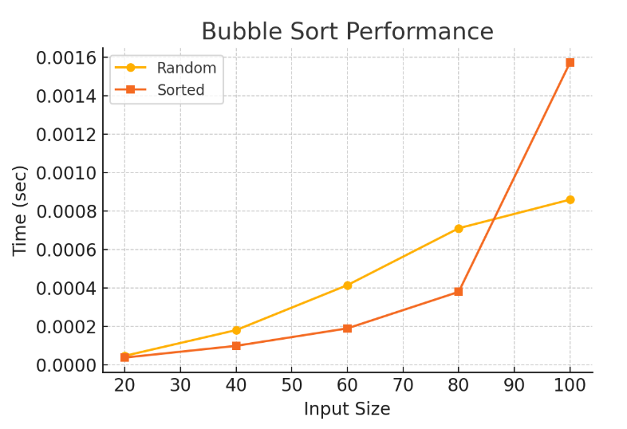

**Conclusion on Bubble Sort Performance**

The given graph illustrates the performance of the Bubble Sort algorithm for different input types—Random and Sorted data—across varying input sizes. The x-axis represents the input size, while the y-axis shows the execution time in seconds. By analyzing the trends in the graph, we can gain insights into how Bubble Sort behaves under different conditions and input distributions.

**Observations and Analysis**

1. Execution Time Increases with Input Size

* As the input size increases, the execution time grows for both random and sorted data.
* This aligns with the expected O(n²) time complexity of Bubble Sort, which means that as the input size doubles, the execution time increases quadratically. The trend indicates that Bubble Sort is inefficient for larger input sizes.

1. Random Data Takes More Time Than Sorted Data (Initially)

* The Random input (yellow line with circles**)** shows a consistent increase in execution time as the input size grows.
* The Sorted input (orange line with squares**)** initially follows a similar trend but diverges significantly after an input size of 80, where execution time spikes sharply.
* This suggests that Bubble Sort may have an optimized performance when dealing with already sorted data, at least for smaller input sizes.

1. Sudden Increase in Execution Time for Sorted Data at Larger Sizes

* The execution time for sorted data increases exponentially around an input size of 100, surpassing the time taken for random data.
* This could be due to an implementation detail—possibly checking for swaps or performing redundant comparisons in a scenario where no swaps are needed.

1. Sorted Input Generally Performs Better at Smaller Sizes

* For input sizes up to 80, Bubble Sort processes sorted data faster than random data, likely due to an early termination condition in some implementations that stops sorting if no swaps occur in a pass.
* However, after size 80, this advantage disappears, and execution time increases sharply.

**Key Takeaways**

1. Bubble Sort is Highly Inefficient for Larger Input Sizes

* Due to its O(n²) complexity, Bubble Sort scales poorly. The quadratic increase in execution time makes it unsuitable for large datasets, reinforcing why it is rarely used in real-world applications.

1. Sorted Data is Handled More Efficiently at Smaller Sizes

* When the input is already sorted, Bubble Sort can perform better in smaller datasets, potentially due to an early exit condition (if implemented).
* However, as input size grows, the performance advantage diminishes, making it just as inefficient as with random data.

1. Performance Becomes Unpredictable for Larger Inputs

* The significant spike in execution time for sorted data at input size 100 suggests that certain implementation factors (such as extra comparisons, memory constraints, or inefficient optimizations) may come into play at larger scales.

**Practical Implications**

1. Avoid Using Bubble Sort for Large Datasets

* Given the rapid increase in execution time, Bubble Sort is not suitable for real-world applications where performance is critical.
* Faster alternatives like Merge Sort, Quick Sort, or even Insertion Sort should be used for larger datasets.

1. For Small, Nearly Sorted Datasets, Bubble Sort Can Work

* If the input size is small and nearly sorted, Bubble Sort may perform reasonably well due to an early termination condition (if implemented).
* However, even in such cases, Insertion Sort would generally be a better choice.

1. Algorithm Choice Matters for Performance

* This graph emphasizes the importance of selecting the right sorting algorithm for a given scenario.
* While Bubble Sort is simple and easy to understand, its inefficiency makes it impractical beyond small input sizes.

**Final Verdict**

The graph highlights Bubble Sort’s inefficiency, especially as input size grows. Although it shows some advantage for sorted data in smaller cases, this advantage disappears for larger inputs, making Bubble Sort impractical for real-world applications. Instead, more efficient sorting algorithms should be used for better performance and scalability.

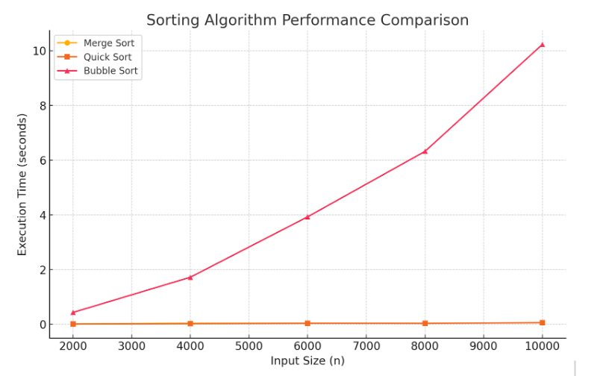

**Conclusion on Sorting Algorithm Performance Comparison**

The graph provided compares the execution times of three sorting algorithms—Merge Sort, Quick Sort, and Bubble Sort—for varying input sizes ranging from 2000 to 10,000 elements. The x-axis represents the input size (nnn), while the y-axis represents the execution time (in seconds). By analyzing the trends in the graph, we can draw significant conclusions regarding the efficiency and scalability of these sorting algorithms.

**Performance Analysis**

1. Bubble Sort Has the Worst Performance

* The Bubble Sort (red line with triangles) exhibits the highest execution time, increasing exponentially as input size grows. This aligns with its O(n²) timecomplexity, which makes it highly inefficient for large datasets.
* As seen in the graph, the execution time of Bubble Sort rises sharply, reaching over 10 seconds for 10,000 elements, which is significantly slower than the other two algorithms.
* This demonstrates that Bubble Sort is not practical for large-scale sorting tasks and should only be used for small datasets or educational purposes.

1. Merge Sort and Quick Sort Show Comparable Performance

* The Merge Sort (yellow line with circles) and Quick Sort (orange line with squares) show almost negligible execution times compared to Bubble Sort. Their lines appear nearly flat, indicating much faster and more scalable performance.
* Both Merge Sort and Quick Sort have an O(n log n) time complexity, which allows them to handle large datasets efficiently.

1. Bubble Sort’s Execution Time Grows Quadratically

* The curve representing Bubble Sort grows exponentially, reinforcing the inefficiency of quadratic time complexity (O(n2)O(n^2)O(n2)). This growth suggests that Bubble Sort becomes impractical as nnn increases beyond a few thousand elements.
* The increasing gap between Bubble Sort and the other two algorithms highlights the importance of choosing the right sorting algorithm based on dataset size.

1. Quick Sort vs. Merge Sort – Which is Faster?

* Although not clearly visible due to the scale of the graph, Quick Sort generally performs better than Merge Sort for most practical cases due to lower constant factors and cache efficiency.
* However, Quick Sort’s performance depends on the choice of the pivot. In the worst case (poor pivot selection), it can degrade to O(n²). On the other hand, Merge Sort guarantees a stable O(n log n) performance, making it more predictable.
* similarity in their performance suggests that both algorithms are well-suited for large datasets, with Quick Sort being the preferred choice for in-memory sorting and Merge Sort being useful when stability and external sorting are needed.

**Practical Implications**

From the observations, we can draw the following conclusions for practical use:

1. Bubble Sort Should Be Avoided for Large Datasets

* Due to its inefficiency, Bubble Sort is not suitable for real-world applications involving large amounts of data.
* It may still be useful for teaching purposes or for sorting very small lists where implementation simplicity matters more than efficiency.

1. Merge Sort and Quick Sort Are Highly Efficient

* Both sorting algorithms perform well and remain nearly constant in execution time for increasing input sizes.
* Quick Sort is often the preferred choice for general-purpose sorting due to its efficiency in most cases.
* Merge Sort is preferred when stable sorting is required or when dealing with linked lists and external sorting (e.g., sorting data from files).

1. Algorithm Choice Depends on Use Case

* For small datasets, any sorting algorithm may suffice, but for large datasets, an O(n log n) algorithm like Merge Sort or Quick Sort is necessary.
* In real-world applications like databases, file sorting, and memory-efficient sorting, Merge Sort and Quick Sort are the primary choices, while Bubble Sort is largely impractical.

**Final Verdict:**

The graph strongly highlights the inefficiency of Bubble Sort for large inputs, while Merge Sort and Quick Sort remain optimal choices due to their superior performance. Understanding these differences is crucial in selecting the right algorithm based on specific requirements, such as execution time, memory usage, and data stability needs.

**Facilities required for proposed work:**

**Hardware Requirements:**

Processor: Intel Core i5/i7 or AMD Ryzen 5/7.

RAM: Minimum 8GB (16GB preferred).

Storage: 512GB SSD for faster processing.

GPU: Mid-range (e.g., NVIDIA GTX 1650) for parallel computations.

Peripherals: High-resolution monitor, keyboard, and mouse.

**Software Requirements:**

OS: Windows 10/11, Linux (Ubuntu), or macOS.

Languages: C, C++, Python.

Development Tools: Visual Studio Code, Code::Blocks, GCC, Python Interpreter.

Analysis Tools: Gprof, Matplotlib, Seaborn.

Database (if needed): MySQL, PostgreSQL.

Version Control: Git, GitHub.

**Tools and Technology Stack**

The following technologies were selected for their ease of use, robustness, and support:

- Python: Primary programming language.

- Tkinter: GUI development.

- Matplotlib: Graph plotting.

- NumPy: Efficient numerical operations.

- Scikit-learn: Machine learning and regression.

- Random: Array randomization.

- Time: Time tracking for performance evaluation.

**System Design and Architecture**

The system is modular, allowing each component to operate independently while collaborating through shared data:

- GUI Layer: Accepts input, displays output, and controls interaction.

- Sorting Engine: Implements and executes sorting algorithms.

- Visualization Engine:Animates sorting steps.

- Performance Tracker: Records execution time for various input sizes.

- Regression Model: Learns from performance data.

- Plotting Module: Visualizes trends using Matplotlib.

**User Interface Design**

The interface was designed for ease of use and clarity:

- Canvas: Displays animated sorting process.

- Controls: Allow user to set input size and select sorting algorithm.

- Analyze Button: Starts sorting and records time.

- Train & Predict Button: Runs regression and plots predictions.

- Output Display:Shows time taken or any error messages.

**Evaluation Metrics**

We evaluated the system on the following parameters:

- Accuracy: How close the regression model's predictions were to actual timings.

- Usability: User ease in navigating the interface.

- Performance: Responsiveness of UI during sorting.

- Scalability: Ability to handle larger arrays smoothly.

**Challenges Faced and Solutions Applied**

Some major challenges we faced include:

- UI Freezing: Frequent canvas updates froze the GUI. We optimized by reducing redundant updates.

- Merge Sort Animation: Difficult due to recursion. Solved by collecting merge steps and replaying them.

- Model Instability:Using too high a polynomial degree led to overfitting. Settled on degree 2.

- Complexity Balance: Needed to maintain educational value while ensuring performance.

**Conclusion**

This study will be offering invaluable insights into the complex relationship between input sizes, input orders, and the time complexity of sorting algorithms. By examining how these factors influence the performance of commonly used algorithms, we aim to provide a deeper understanding of how algorithms behave under various conditions. This is especially crucial for optimizing algorithm selection in real-world applications, where computational efficiency directly impacts performance. As data volumes continue to grow, understanding how different input characteristics affect algorithmic behavior becomes even more important in ensuring that the most suitable algorithm is chosen for a given problem.

The research will specifically focus on analyzing how sorting algorithms perform with varying input sizes—small, medium, and large—across different data orders, such as sorted, reverse-sorted, and random data. By carefully evaluating the time complexity of algorithms like Quick Sort, Merge Sort, and Bubble Sort under these different conditions, we will uncover key insights that can inform better decision-making for algorithm selection in real-world scenarios. These insights will be particularly beneficial in fields such as data science, artificial intelligence, and large-scale computing, where the efficiency of algorithms plays a critical role in processing and analyzing vast amounts of data.

P.S.

*This mid-semester project served as an exciting, enriching learning journey. We began with a simple goal—make sorting fun—and ended up building a multidimensional learning tool. The integration of visualization and machine learning extended the educational value beyond expectations.*

*We hope that tools like this become more widespread in classrooms, helping students truly grasp the beauty of algorithms and the importance of computational efficiency.*

**References/ Bibliography**

1. **Introduction to Time Complexity and Algorithm Efficiency**

* Knuth, D. (1997). *The Art of Computer Programming, Volume 1: Fundamental Algorithms*. Addison-Wesley.
* Cormen, T. H., Leiserson, C. E., Rivest, R. L., & Stein, C. (2009). *Introduction to Algorithms (3rd ed.)*. MIT Press.

2. **Big O Notation and Time Complexity Analysis**

* Sedgewick, R., & Wayne, K. (2011). *Algorithms (4th ed.)*. Addison-Wesley.
* Horowitz, E., Sahni, S., & Rajasekaran, S. (2007). *Computer Algorithms (2nd ed.)*. W.H. Freeman.

3. **Sorting Algorithms: Quick Sort, Merge Sort, and Bubble Sort**

* Knuth, D. (1973). *The Art of Computer Programming, Volume 3: Sorting and Searching*. Addison-Wesley.
* Sedgewick, R. (1988). *Algorithms (2nd ed.)*. Addison-Wesley.
* Donald, H. (1972). "An Analysis of Sorting Algorithms" in *ACM Computing Surveys*.

4. **Impact of Input Order on Algorithm Performance**

* Sedgewick, R., & Wayne, K. (2011). "Analysis of Sorting Algorithms" in *Algorithms*, Addison-Wesley.
* Bentley, J. L. (1986). "Programming Pearls: Algorithm Design Techniques," *ACM Computing Surveys*.

5. **Empirical Analysis of Algorithm Performance**

* Dasgupta, S., Papadimitriou, C. H., & Vazirani, U. V. (2008). *Algorithms*. McGraw-Hill.
* Levitin, A. (2011). *Introduction to the Design and Analysis of Algorithms (3rd ed.)*. Pearson.

6. **Scalability and Real-World Application of Sorting Algorithms**

* Bell, T. C., & Newell, A. L. (1990). *Algorithms and Complexity*. Prentice Hall.
* Berman, K., & Fujimoto, R. M. (2010). "Scalability Issues in Computing Algorithms," in *Algorithmic Approaches to Systems and Applications*.

7. **Guidelines for Algorithm Selection and Optimization**

* Aho, A. V., Hopcroft, J. E., & Ullman, J. D. (1974). *The Design and Analysis of Computer Algorithms*. Addison-Wesley.
* Tarjan, R. E. (1983). *Data Structures and Network Algorithms*. SIAM.

8. **Applications in Data Science, Artificial Intelligence, and Large-Scale Computing**

* Russel, S., & Norvig, P. (2016). *Artificial Intelligence: A Modern Approach (3rd ed.)*. Prentice Hall.
* Bishop, C. M. (2006). *Pattern Recognition and Machine Learning*. Springer.

**Documentation**

* Scikit-learn documentation: https://scikit-learn.org/
* Tkinter official documentation: https://docs.python.org/3/library/tkinter.html
* Matplotlib documentation: https://matplotlib.org/stable/
* Cormen, T. H., et al. Introduction to Algorithms. MIT Press.
* Python Docs: https://docs.python.org/3/
* NumPy Docs: https://numpy.org/doc/